**A**

**PROJECT REPORTON**

**MATERIALS STOCK MANAGEMENT SYSTEM FOR JORHAT ELECTRICAL CIRCLE OF APDCL**



**A software project submitted in partial fulfillment for the award of the Degree of**

**Master of Computer Application (M.C.A.)**

**Dibrugarh University, Dibrugarh (Assam)**

**Session: 2016 – 2019**

# Under the guidance of

Internal Guide Organizational Guide

**Dr. Siddhartha Baruah Mr. Arindom Nath**

Assistant Professor Assistant General Manager

Department of Computer Applications (HR)

Jorhat Engineering College APDCL,Jorhat El Circle

Jorhat-01,Assam

**Submitted By**

**Trinayan Sankar Das**

Roll No: 13220019

Reg-No: 1201 of 2013-2014

MCA 6th Semester

Jorhat Engineering College Jorhat, Assam

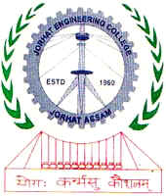

**DEPARTMENT OF COMPUTER APPLICATION**

**JORHAT ENGINEERING COLLEGE, JORHAT**